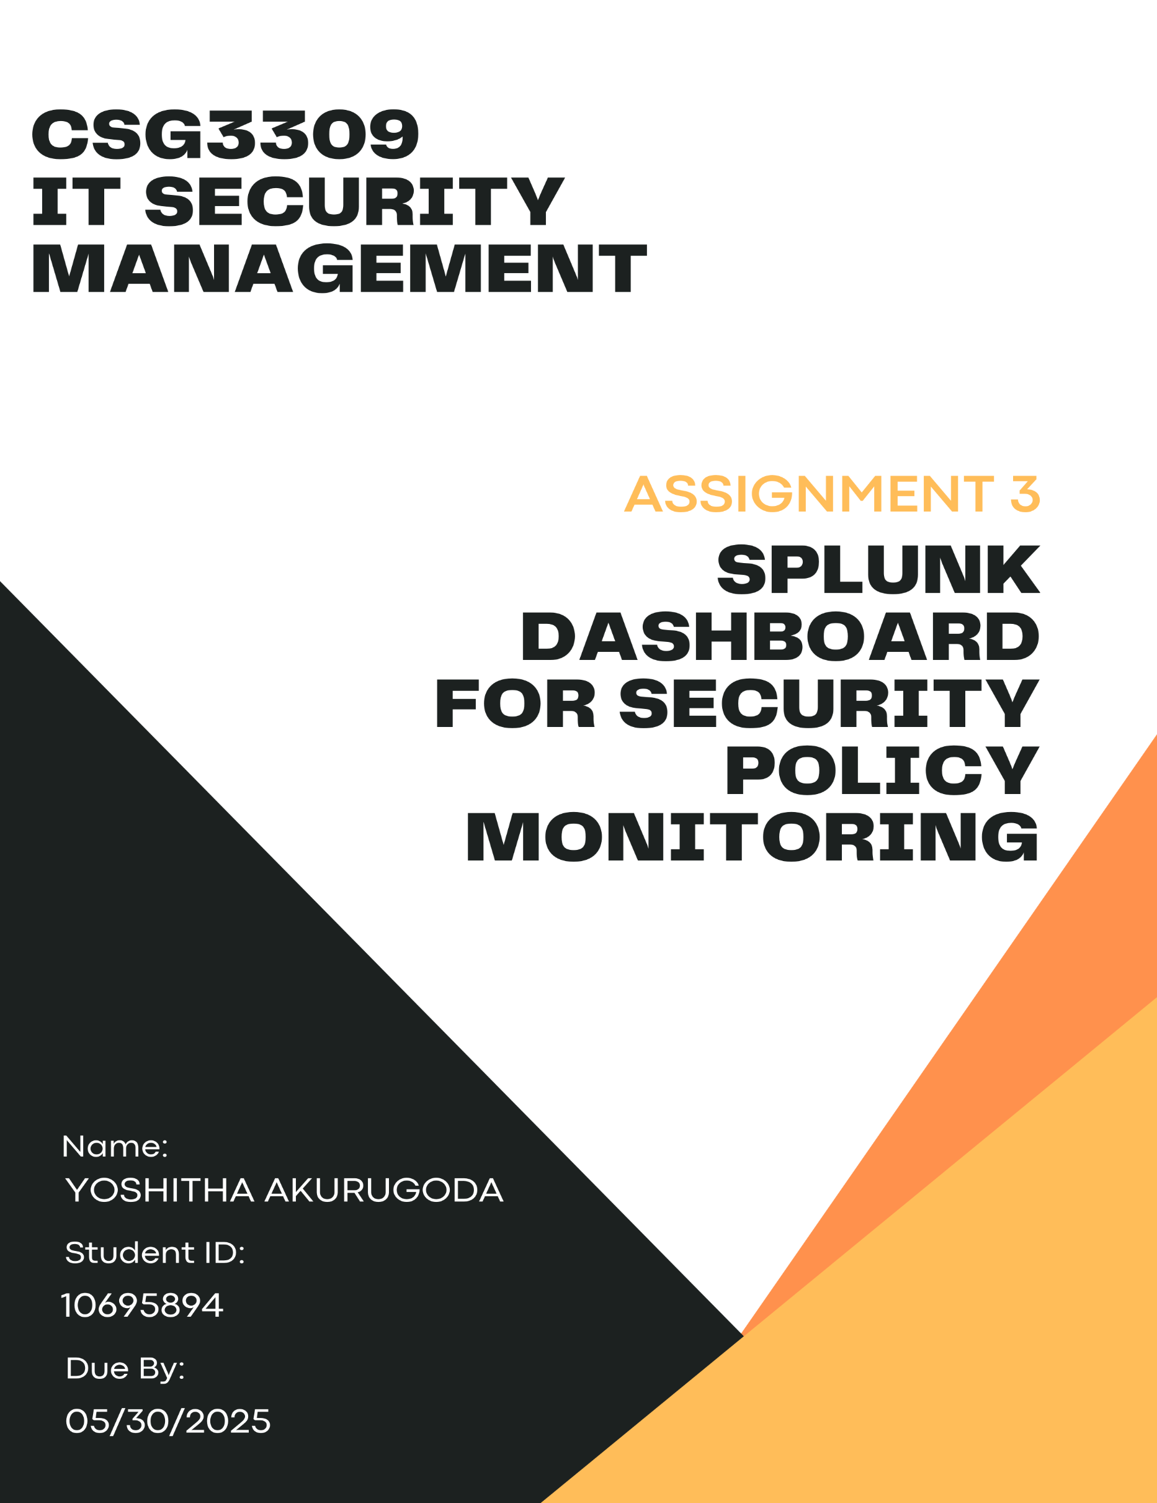

Table of Contents
1. Introduction 2
2. Security Policy Overview 3
3. Dashboard Summary 3
4. Dashboard Panels & Analysis 5
4.1 Panel 1 – Top External Connections by Host 5
4.2 Panel 2 – External Connections Over Time 6
4.3 Panel 3 – External Port Usage Breakdown 7
4.4 Panel 4 – Top Users by Event Count 9
5. Management Justification & Dashboard Value 10
References 11

1. Introduction
Sutrefia (Sunken Treasure Financials Australia) handles highly sensitive client information and as a result becomes a prime target for cyber-attacks. To protect this information, the company strictly follows strict security policies based on the Australian Government’s Information Security Manual (Australian Cyber Security Centre [ACSC], 2024).
Among the most important policies are Endpoint Security and Unauthorized Software, whose purpose is to minimize the exposure of the system to only approved software. Unauthorized usage of tools like Mimikatz or PowerShell often indicates a breach of this policy (Splunk, 2020).
To strengthen its monitoring capabilities, Sutrefia is trialing Splunk, a leading SIEM platform known for its ability to provide real-time threat detection and customizable dashboards (Spunk, 2024). This report presents a Splunk dashboard built using the BOTSv3 dataset, which simulates real-world attack data for evaluation and training purposes (Splunk, 2020).
The goal of this report is to show how Splunk can translate technical security can translate technical security data into high-level visuals that help non-technical managers identify policy breachers and take appropriate action (Mosse Cyber Security Institute, 2023; SearchInform, n.d.).

2. Security Policy Overview
The security policy monitored in this report is Endpoint Security & Unauthorized Software, which focuses on preventing the use of unapproved or malicious programs on organizational devices. According to Sutrefia’s Internal guidelines, only authorized applications are permitted to run on desktops, laptops and servers, with any software installations or executions managed strictly by the IT and Security Operations teams.
This policy aligns with the Australian Government’s Information Security Manual, which advises organizations to control executable code and restrict applications to minimize vulnerabilities and reduce the attack surface (ACSC, 2024).
Violations of this policy may indicate potential compromise. Common signs include:
- Execution of known hacking tools (e.g. Mimikatz, Cain, Netcat)
- Use of suspicious PowerShell commands or scripts
- File hashes associated with malware.
- Unusual activity spikes from endpoints
The BOTSv3 dataset simulates such scenarios, making it ideal for visualizing how Splunk can detect these violations (Splunk, 2020). By identifying unusual patterns in software execution, host behavior or user activity, Splunk dashboards can help management ensure policy compliance and detect early signs of threat actors (SearchInform, n.d.).

3. Dashboard Summary
This Splunk dashboard has been designed to help Sutrefia’s management visually detect breaches of the Endpoint Security & Unauthorized Software policy. It provides an at-a-glance view of key indicators that suggest unauthorized or malicious programs have been executed across the organization’s network.
The dashboard contains four panels, each offering a unique perspective on potential policy violations:
- Panel 1 shows the number of suspicious executables detected per host.
- Panel 2 displays a time series of these events to highlight spikes or ongoing misuse.
- Panel 3 identifies the user most frequently associated with suspicious software.
- Panel 4 presents file hash results that match known malware signatures.
These panels were developed using BOTSv3 dataset, which simulates real-world attack scenarios (Splunk, 2020). The SPL (Search Processing Language) queries behind each panel were customized to extract meaningful, policy-relevant insights. Together, the dashboard enables managers to quickly assess the scale and source of potential violations without needing deep technical expertise (Mosse Cyber Security Institute, 2023).
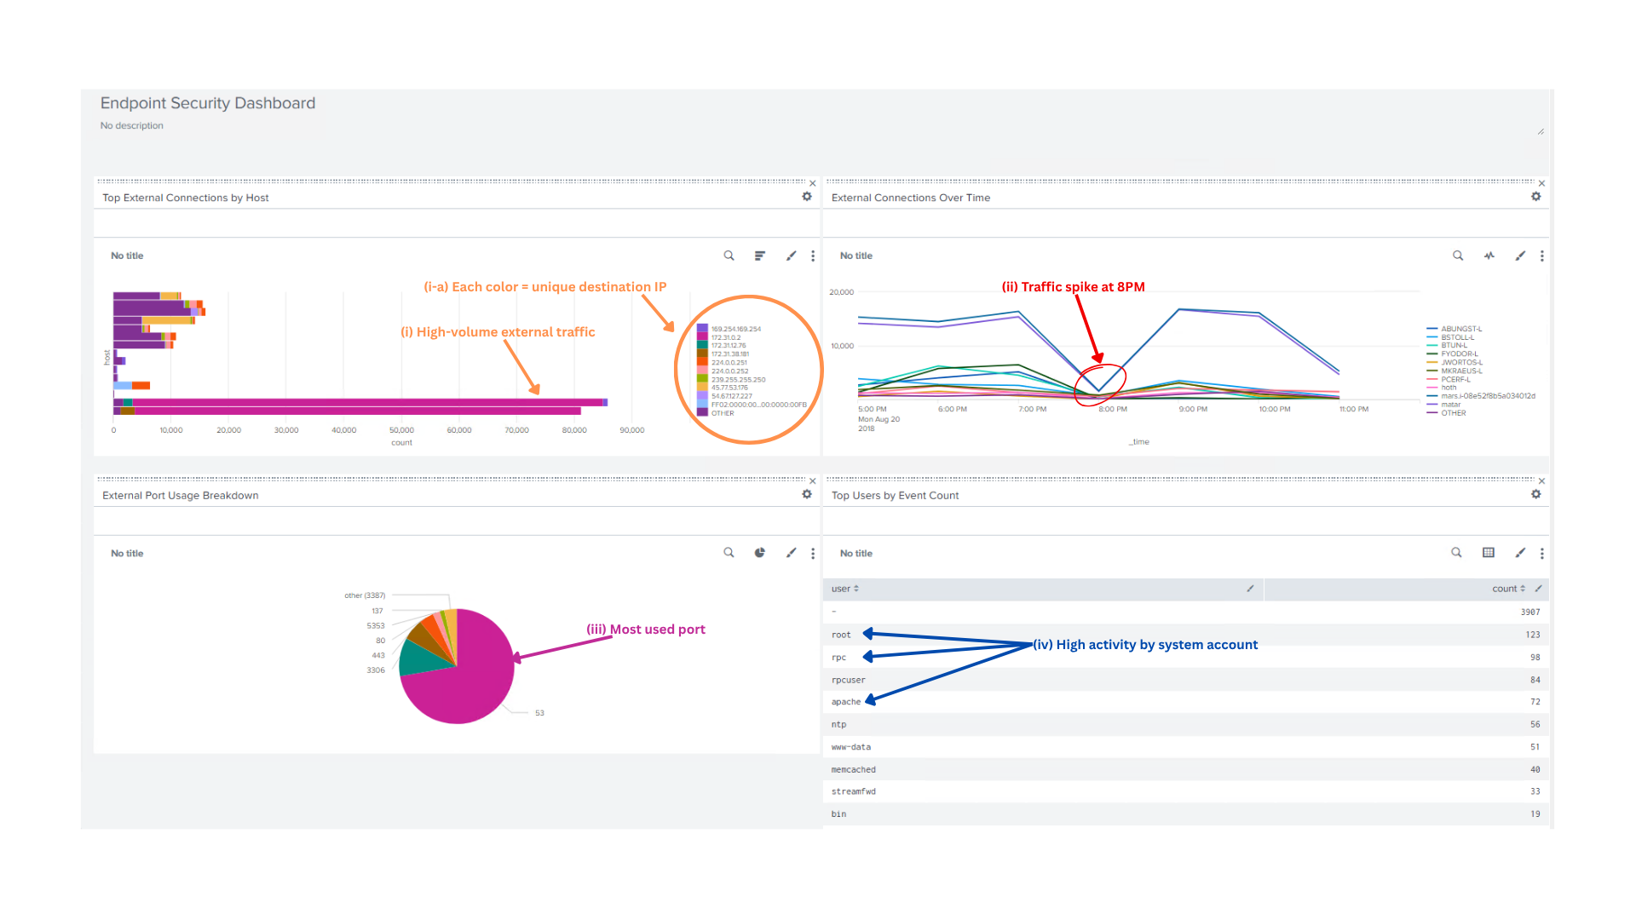
Visual Overview of Endpoint Security Dashboard Panels

Figure 1. Annotated Splunk Dashboard Overview
(i) High-volume external traffic — One host stands out with significantly more connections than others, indicating compromise or unauthorized tools.
(i-a) Each color = unique destination IP — Multiple destination IPs for a single host indicate a wide range of external communication, which may violate endpoint restrictions.
(ii) Traffic spikes at 8PM — A sharp rise in outbound activity suggests suspicious behavior like beaconing or automated scans.
(iii) Most used port — DNS (port 53) dominates outbound traffic, which is expected, but should still be monitored for tunneling activity.
(iv) High activity by system account — Accounts like root or Apache with high event counts may be overused, misconfigured, or exploited.

4. Dashboard Panels & Analysis

4.1 Panel 1 – Top External Connections by Host
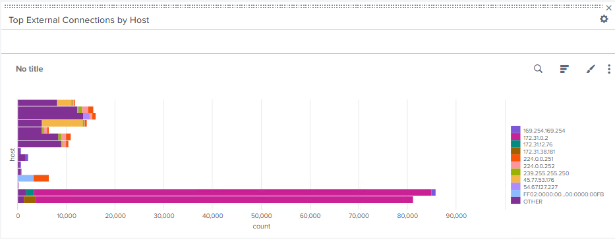

Figure 1.1 – Panel 1 – Top External Connections by Host
Purpose of the Panel
This panel displays outbound connection activity from internal hosts to external IP addresses. Each host is represented by a stacked bar, where each colored segment shows the number of connections to a specific destination IP.
The goal is to detect endpoints that ay be engaging in suspicious or unauthorized network behavior – such as contacting unknown or malicious servers – which would violate Sutrefia’s Endpoint Security & Unauthorized Software policy (ACSC, 2024).
Visual Type
- Chart Type : Stacked Bar Chart
- X-Axis: Internal Hostnames
- Y-Axis: Total outbound connections count
- Count Splits : External IP addresses.
This visualization allows stakeholders to quickly spot which systems are producing large volumes of traffic and to whom they are connecting.
Why it’s Used
This panel transforms raw event data into a readable, high-level view that highlights:
- High-risk systems with abnormal external communication
- Potential lateral movement or malware callback behavior
- IP addresses that might be connected to threat actors.
It allows non-technical managers to assess risk exposure without needing to interpret low-level logs (Moss Cyber Security Institute, 2023)
SPL Used:
index=botsv3 src_ip=* dest_ip=*
| where NOT like(dest_ip, "10.%") AND NOT like(dest_ip, "192.168%") AND NOT like(dest_ip, "172.16%")
| chart count over host by dest_ip
| sort -count

4.2 Panel 2 – External Connections Over Time
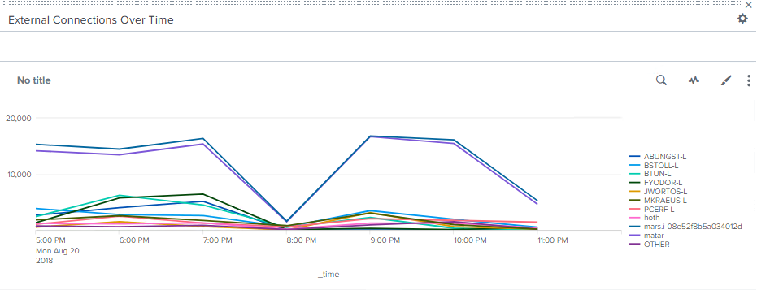

Figure 1.2 Panel 2 - External Connections Over Time
Purpose of the Panel
This panel displays the number of outbound connections from internal systems to external IP addresses, tracked over time. It provides a time-series view to view identify periods of abnormal connection activity, which may signal malware behavior, automated tasks, or data exfiltration attempts.
Monitoring network activity over time helps enforce Sutrefia’s Endpoint Security & Unauthorized Software policy by detecting unexpected spikes in external communications, especially from workstations that shouldn’t be generating high volumes of outbound traffic. Visual Type
- Chart Type: Line Chart
- X-Axis: Time (Hourly Intervals)
- Y-Axis: Number of external connections
This visual simplifies large volumes of connections logs into trend patterns, making it easy for management to spot irregular behavior.
Why it’s Used
Spikes in outbound connections are often early indicators of compromise, such as:
- Malware beaconing to a command-and-control server.
- Unauthorized data uploads
- Scheduled unauthorized tasks (e.g. PowerShell scripts running hourly)
By monitoring the when, this panel complements others that focus on the who and what (e.g. Hosts or users), giving a complete picture of policy violations (Splunk, 2024; Mose Cyber Security Institute, 2023).
SPL Used
index=botsv3 src_ip=* dest_ip=*
| where NOT like(dest_ip, "10.%") AND NOT like(dest_ip, "192.168%") AND NOT like(dest_ip, "172.16%")
| timechart span=1h count by host
This SPL filters for external connections only and summarizes them over time in hourly buckets to reveal spikes in activity.

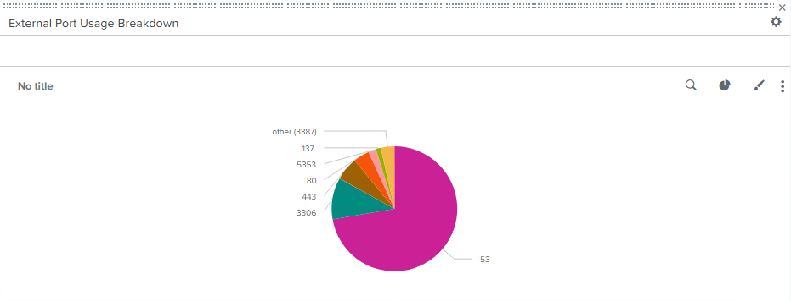
4.3 Panel 3 – External Port Usage Breakdown

Figure 1.3 Panel 3 – External Port Usage Breakdown
Purpose of the Panel
This panel identifies the most frequently used destination ports in outbound connections from internal systems. Ports are often linked to specific services, and unexpected or unauthorized port usage can indicate risky or malicious behavior – such as command-and-control channels or unapproved remote access.
This panel supports Sutrefia’s Endpoint Security & Unauthorized Software policy by providing visibility into potential misuse of network protocols or unsanctioned applications (ACSC, 2024).
Visual Type
- Chart Type: Pie Chart
- Field: dest_port
- Value: Count of connections per port
The pie chart clearly shows which ports dominate network activity, helping management detect anomalies at a glance.
Why Its Used
Certain ports (e.g. 21 for FTP, 22 for SSH, 3389 for RDP, 25 for SMTP) are known vectors for attacks or unauthorized behavior. This panel helps:
- Highlight high-risk ports being accessed.
- Flag deviation from expected network usage.
- Inform firewall and endpoint policy tuning.
Even non-technical users can visually interpret which ports are used most frequently and whether they align with business operations (Splunk, 2024; Mosse Cyber Security Institute. 2023).
SPL Used
index=botsv3 dest_port!=""
| stats count by dest_port
| sort -count
This SPL summarizes external connection activity by destination port across all hosts.

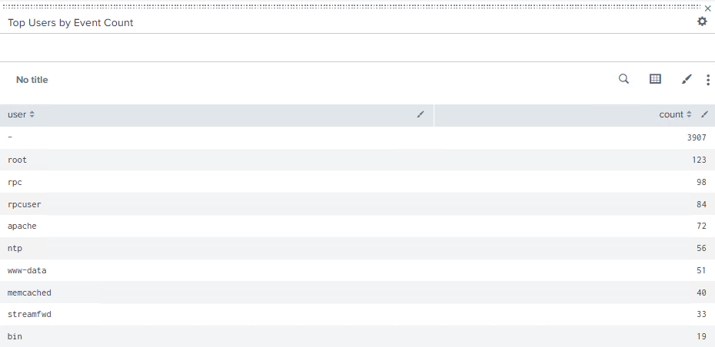
4.4 Panel 4 – Top Users by Event Count

Figure 1.4 Panel 4 – Top Users by Event Count
Purpose of the Panel
This panel lists user accounts that are generating the most logged security events in the system. Elevated activity from accounts like root, Apache, or service accounts (e.g. rpc, Memcached) can indicate misconfiguration, abuse or even compromise.
Tracking user behavior supports Sutrefia’s Endpoint Security and Access Control policies by revealing potential violations tied to specific identities or roles.
Visual Type
- Chart Type: Table
- Columns: user, count
- Sorted: Descending by activity volume
This clean format makes it easy for management to see which accounts are active and whether that aligns with expected behavior.
Why Its Used
High event counts from unexpected accounts – especially system accounts or users not known to perform heavy activity – can signal:
- Abuse of privileged credentials
- Unauthorized services
- Suspicious automated behavior
Managers can cross-reference this view with internal HR/accounting logs to confirm legitimate access or escalate anomalies (ACSC, 2024; Splunk Docs, 2024).
SPL Used
index=botsv3 user!=""
| stats count by user
| sort -count
This SPL counts how many events are associated with each user in the dataset.

5. Management Justification & Dashboard Value
In conclusion, this Splunk dashboard provides Sutrefia’s management with useful visual and data-focused means to assess monitoring of the Endpoint Security & Unauthorized Software policy. Instead of needing to interpret raw logs or technical reports, management now has the opportunity to see how systems and their users are acting in real time, with visual explanations and hard data all on one page.
Every panel of the dashboard was designed to be actionable and informative:
- Panel 1 does outbound connections to external IPs and will help identify compromised hosts.
- Panel 2 shows connection volume over time and shows rapid spikes that represent attack (e.g. flood, reconnaissance) or periods of abnormal activity.
- Panel 3 represents external port usage. This information allows for identifying unauthorized services and suspicious tunneling activity.
- Panel 4 shows the user most active in terms of connections. This assists with identifying potential misuse of privileged accounts or identifying anomalous behavior.
The value of each panel can be viewed as translating the technical data into actionable decisions, by allowing executives to:
- Identify violations faster.
- Support investigations of incidents.
- Prepare for immediate corrective actions based on notifiable risk indicators.
With the automation and visualizations that Splunk is capable of, this dashboard has enabled Sutrefia to continuously verify policy compliance with very little human input. This not only creates a reference for internal security auditing but also builds on Sutrefia's security defense against continuous and evolving threats, (e.g. ACSC, 2024; Splunk, 2024).

References
Australian Cyber Security Centre. (2024). Information security manual (ISM). https://www.cyber.gov.au/acsc/view-all-content/ism
Mosse Cyber Security Institute. (2023). SIEM dashboards: Invaluable data sources for incident investigations. https://library.mosse-institute.com/articles/2023/09/siem-dashboards.html
SearchInform. (n.d.). Data loss prevention uses cases. https://searchinform.com/blog/2022/11/04/data-loss-prevention-use-cases/
Splunk. (2024). Splunk search language reference guide. https://docs.splunk.com/Documentation/Splunk/latest/Search/AboutSplunkssearchlanguage

